D I T T O N P A R I S H C O U N C I L

MINUTES OF A MEETING OF THE PLANNING HIGHWAYS & TRANSPORTATION COMMITTEE HELD IN THE COUNCIL CHAMBER AT DITTON COMMUNITY CENTRE ON MONDAY 19th JUNE 2023.

PRESENT: CLLRS N NEWMAN [CHAIR], M PORTER, A MULCUCK,
D ADLINGTON, A LAIDOUCI, JAMES COX, MRS J DEARDEN, MRS L COX & MRS A THROSSELL,
MRS N GREENAWAY [CLERK TO THE COUNCIL]
MRS G JEFFS [ADMINISTRATIVE ASSISTANT]

60. OPENING OF MEETING

The meeting was opened by the Chairman at 7.30pm.

61. APOLOGIES FOR ABSENCE

No Apologies were received.

62. DECLARATION OF MEMBERS’ INTERESTS

None received .

63. PLANS RECEIVED FOR COMMENT:

- TM/23/01029/RD Redevelopment site know as Panattoni Park, Bellingham Way, Aylesford, Kent
Details of condition 11 (part 4 only Verification report) 12 (Verification report) 18 (verification report) pursuant to Planning permission TM/20/01820/OAEA Outline Application: Hybrid planning application for the following development: Outline planning permission (all matters reserved) for the erection of flexible B1c/B2/B8 use class buildings and associated access, servicing, parking, landscaping, drainage, remediation and earthworks; and, Full planning permission for erection of two warehouse buildings for flexible B1c/B2/B8 use class, realignment of Bellingham Way link road, creation of a north/south spine road, works to the embankment of Ditton Stream, demolition of existing gatehouse and associated servicing, parking, landscaping, drainage, infrastructure and earthworks.

RESOLVED THIS COUNCIL SUPPORTS KCC’S COMMENTS:

We support the findings of KCC and the points that were raised. These were:
The LLFA understand from the report that the drainage system designed and submitted under condition 17 appears to have been constructed. From the supporting CCTV survey report contained within the report, a number of manholes have not been constructed at junctions/ connection points.
Whilst not deemed essential for the functionality of the system, the lack of these can make future access more difficult. Before the condition is discharged, we would request confirmation or photographic evidence that the flow control devices have been installed and to the correct design parameters.

- TM/23/01125/FL – 45 Acorn Grove, Ditton Aylesford Kent ME20 6EL
Two storey side extension and single storey rear extension with monopitch roof and skylight.

RESOLVED THIS COUNCIL HAS NO OBJECTIONS TO THIS APPLICATION.

- TM/23/01273/TPOC – 175 Woodlands Road, Ditton, Aylesford, Kent Me20 6HA
Sweet chestnuts T1 – T8 – overall reduction by approx. 40%. Current height is an average of 19m & lateral spread of 6m so a whole crown reduction of 10m above ground is requested. There is some history of at least one of these trees falling in recent high winds, falling across three of the rear gardens. Standing in woodland W1 of Tree Preservation Order.

RESOLVED THIS COUNCIL HAS NO OBJECTIONS TO THIS APPLICATION SUBJECT TO THE TREE OFFICERS APPROVAL.

64. PLANS DEALT WITH BY TMBC AREA SUB-COMMITTEE ( D LIST)

The following were READ and NOTED:
- TM/23/00544/TPOC - 20 Acorn Grove, Ditton, Kent ME20 6EW
1 X Ash ( applicants ref T1) – Dismantle to ground level due to Ash dieback. Standing in group G3 of Tree Preservation Order.
REFUSED 24.04.2023
- TM/22/02385/FL - 26 Blackthorn Drive, Larkfield, Aylesford, Kent ME20 6NR
First floor extension, loft conversion and extension of garage under existing terrace.
APPROVED 03.05.2023

- TM/23/00139/FL - SEW Site Mill Hall Road, Ditton, Kent
Installation of a new treatment building for water transmission and treatment purposes. APPROVED 04.05.2023

- TM/23/00557/LDP- 17 Scott Close, Ditton Aylesford Kent ME20 6QP
Lawful development certificate proposed: Loft conversion with dormers CERTIFIED 05.05.2023

- TM/23/00646/FL- 57 Medina Road, Ditton, Aylesford, Kent ME20 6DR
Construction of first floor side extension and single storey side extension
APPROVED 12.05.2023

- TM/22/00942/WAS - Unit 4 Invicta Park, New Hythe Lane, Ditton Aylesford Kent ME20 7FG
Continued operation of existing metals recycling facility, including retention of existing plant and buildings, the erection of new fixed plant, buildings and enclosures, an extension of working hours and an increase in permitted stockpile heights Kcc Ref: KCC/TM/0057/2022
APPROVED 18.05.2023

- TM/23/00384/TPOC – 50 Acorn Groce, Ditton, Aylesford, Kent ME20 6EW
1 X Sweet Chestnut (Applicants ref T1) – cut back to previous points ( approx. 3-4 meters. Standing in woodland W1 of Tree Preservation Order.
APPROVED 15.05.2023
- TM/23/00699/FL – 45 St Peters Road, Ditton, Aylesford, Kent ME20 6PF
Single storey side extension and single storey rear extension.
APPROVED 19.05.2023

- TM/23/00708/LDP – 12 St Peters Close, Ditton Aylesford Kent ME20 6PG
Lawful Development Certificate Proposed: Single Storey Side extension.
CERTIFIED 17.05.203

- TM/22/02357/AT – Unit 2 Gill Close, Panattoni Park, Aylesford, Kent ME20 7XL
Signage for new Evri depot
APPROVED 30.05.2023

- TM/23/00447/FL – 675 London Road, Ditton, Aylesford, Kent, ME20 6DF
Variation of Condition 9 ( opening hours) pursuant to planning permission TM/19/02841/FL (class A1 foodstore) to permanently allow the store to trade on bank holidays from 08.00 until 20.00.
APPROVED 26.05.2023

- TM/23/00701/TPOC – St Peter Ad Vincila Church, New Road, Ditton, Aylesford, Kent
(A) 1 x Sycamore (applicants ref. Tree 1) - Reduce by 25% and remove deadwood. Standing in Group G1 of Tree Preservation Order reference 84/10325/TPO;
(B) 1 x Holly (applicants ref. T2) - Reduce by 25%. T2 of Tree Preservation Order reference 00/00010/TPO
SPLIT DECISION 26.05.2023

- TM/23/00815/TNCA – St Peters Road, Ditton, Kent ME20 6PJ
T1 - Ash (applicants reference) Stands at the western edge of the car park serving St Peters Court, a retirement housing block which is owned/managed by Clarion Housing. Proposed by the applicant is the crown reduction from current 15m high & 7m lateral spread, to 9m & 5m respectively. T2 -Oak (applicants reference) standing close to the Ash. Current height and lateral spread of 13m and 7m. Proposal is to crown reduce to 9m and 5m respectively.
NO OBJECTION 26.05.2023

- TM/23/00878/FL – 53 Bell Lane, Ditton, Aylesford, Kent ME20 6BT
Single storey rear extension with flat roof and roof lights (revision to TM/23/00152/FL)
APPROVED 30.05.2023

- TM/23/00855/PDVLR – 55 Fernleigh Rise, Ditton, Aylesford, Kent ME20 6BS
Prior notification for residential extension: ( Part 1 class A) single storey rear extension to a depth of 4m, maximum roof height of 3m and eaves height of 3m.
PRIOR APPROVAL NOT REQUIRED 06.06.2023

65. PARKING ACTION PLAN PHASE 14 CONSULTATION

The Parking Action Plan was READ and NOTED. The suggested location of Cherry Orchard was ACCEPTED. It was NOTED that the plans show the yellow lines proposed all the way into the cul-de-sac and this is felt to be a little excessive. It was agreed to suggest the double yellow lines should be just on the corners and at the junction. Cllr Porter suggest that the bend in Woodlands Road would benefit from double yellows as the parked cars make it dangerous. Other members agreed this should be added to a future requests on the parking action plan.

66. KCC HIGHWAYS TREES – ROUTINE SAFETY AUDITS (TSA)
CORRESPONDANCE FOR NOTING

Circulated, READ and NOTED. No Comments were made at this time.

67. SECTION 106 – PLANNING OBLIGATIONS

The current list for potential projects was NOTED:
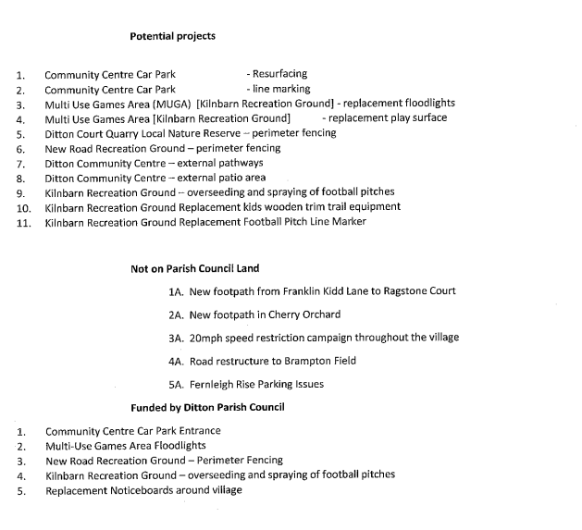
Cllr Newman read the above and asked if any further developments or improvements could be added to this list. It was suggested that path improvements for the Nature Reserve could be considered as in the wet winter months the paths can become very difficult to walk through. It was NOTED that funding had been awarded for the replacement MUGA lights and surface, the wooden trim trail and the line marking equipment.

The Chairman moved that an additional date sensitive item be considered:

68. STREET NAMES AT ORCHARD GATE

It was NOTED that more suggestions were required as some of the previous names given were duplicated in the area. Suggestions of other apple varieties had been supplied by Borough Cllr Cannon. These were agreed apart from Leo and Stella.

---------------------------------------------------------------------------------------------------------------------------- Pursuant to section 1(2) of the Public Bodies (Admission to Meetings) Act 1960 and Standing Orders 27 & 50 the Chairman to move that due to the confidential nature of the next item the Press and Public be excluded from the meeting.

69. BRADBOURNE PROPOSAL

Cllr Newman reported that he and the Clerk had met with the Chairman of East Malling and Larkfield Parish Council earlier that day. It was noted that EMT had attempted to submit the planning application but it had not been possible because there were not sufficient Planning Officers at TMBC currently and some cases were being outsourced to external Planning Consultants. It was more likely that it would be submitted in the Autumn to December.

The contents of the letter from the consultant with The Rural Planning Practice were NOTED and it was also NOTED that East Malling and Larkfield PC would be happy to engage the consultant jointly with Ditton to further pursue the issues she had highlighted as options for objection. Members agreed to share the cost of the consultant with East Malling and Larkfield PC. A draft letter to TMBC pre planning was circulated. The contents were agreed subject to Kilnbarn Lane being amended to Kilnbarn Road and that this letter should be reviewed by the planning consultant prior to sending to TMBC.

70. CLOSURE

The meeting closed at 7.49pm

Chairman
3rd July 2023

